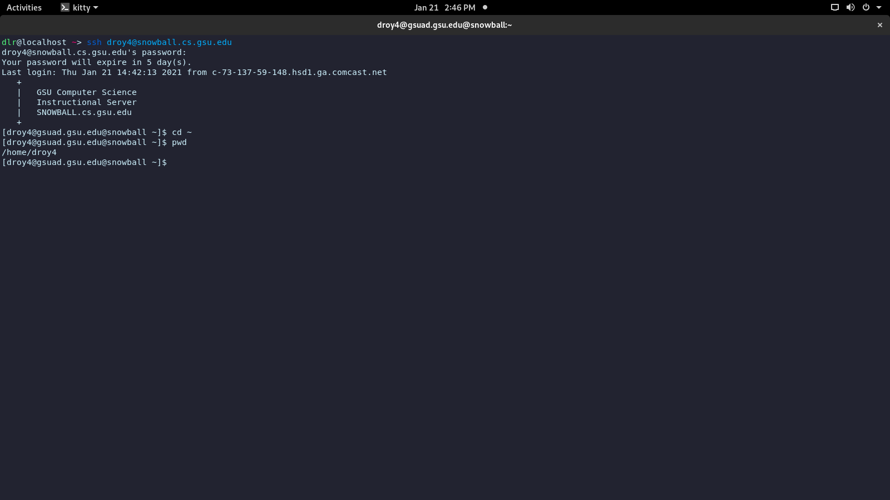

Answer A: The working directory is /home/droy4

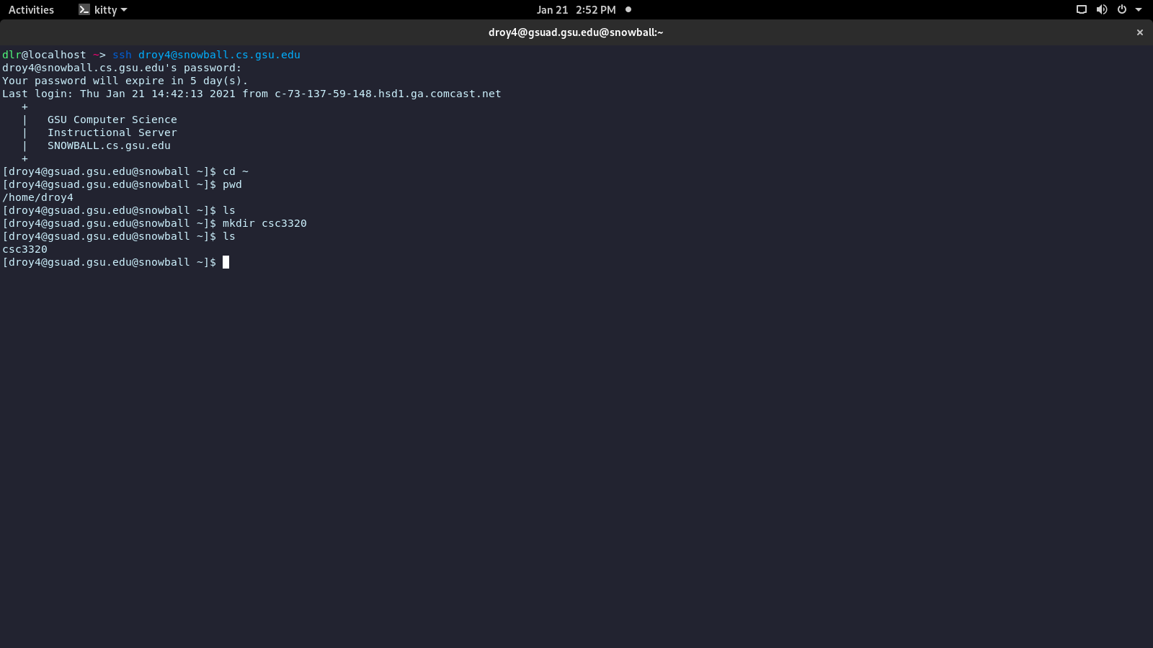

Answer B: The first instance of ls shows nothing, because the directory has no files within it. The second one shoes csc3320, because I created a directory in the directory using mkdir.

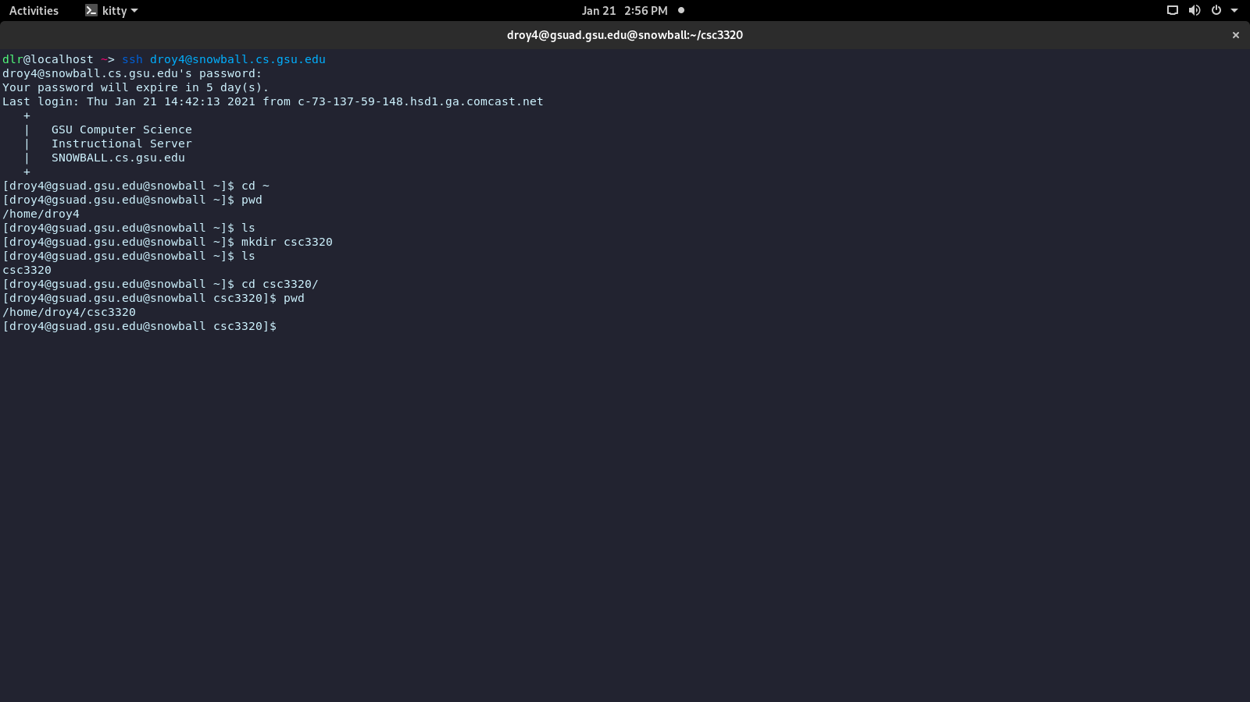

Question C: I used pwd, which prints the working directory.

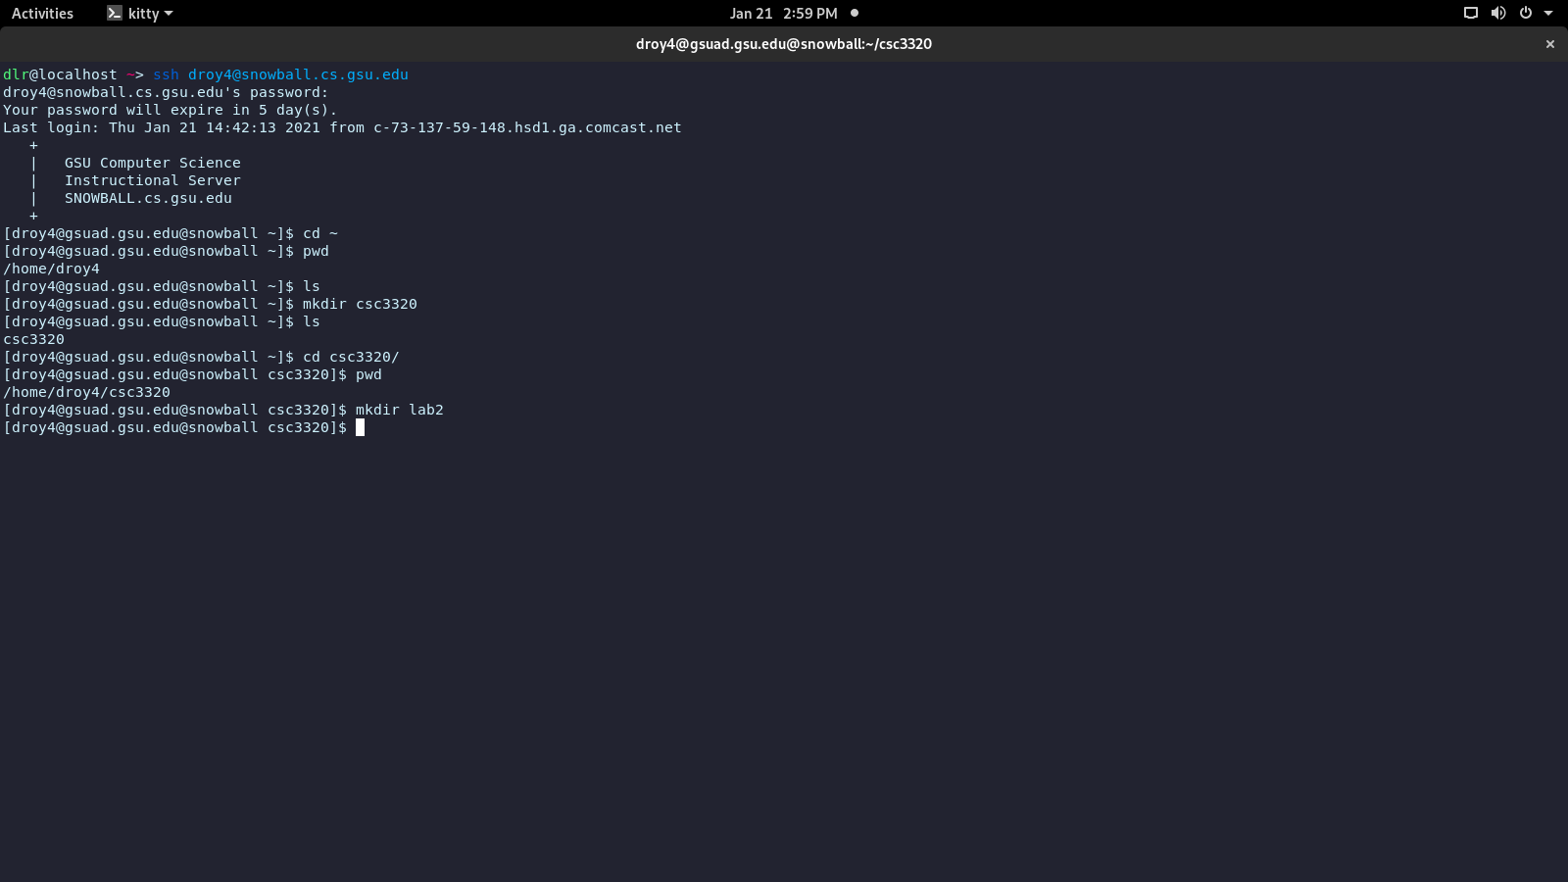

Question D: I used mkdir to create the directory lab2.

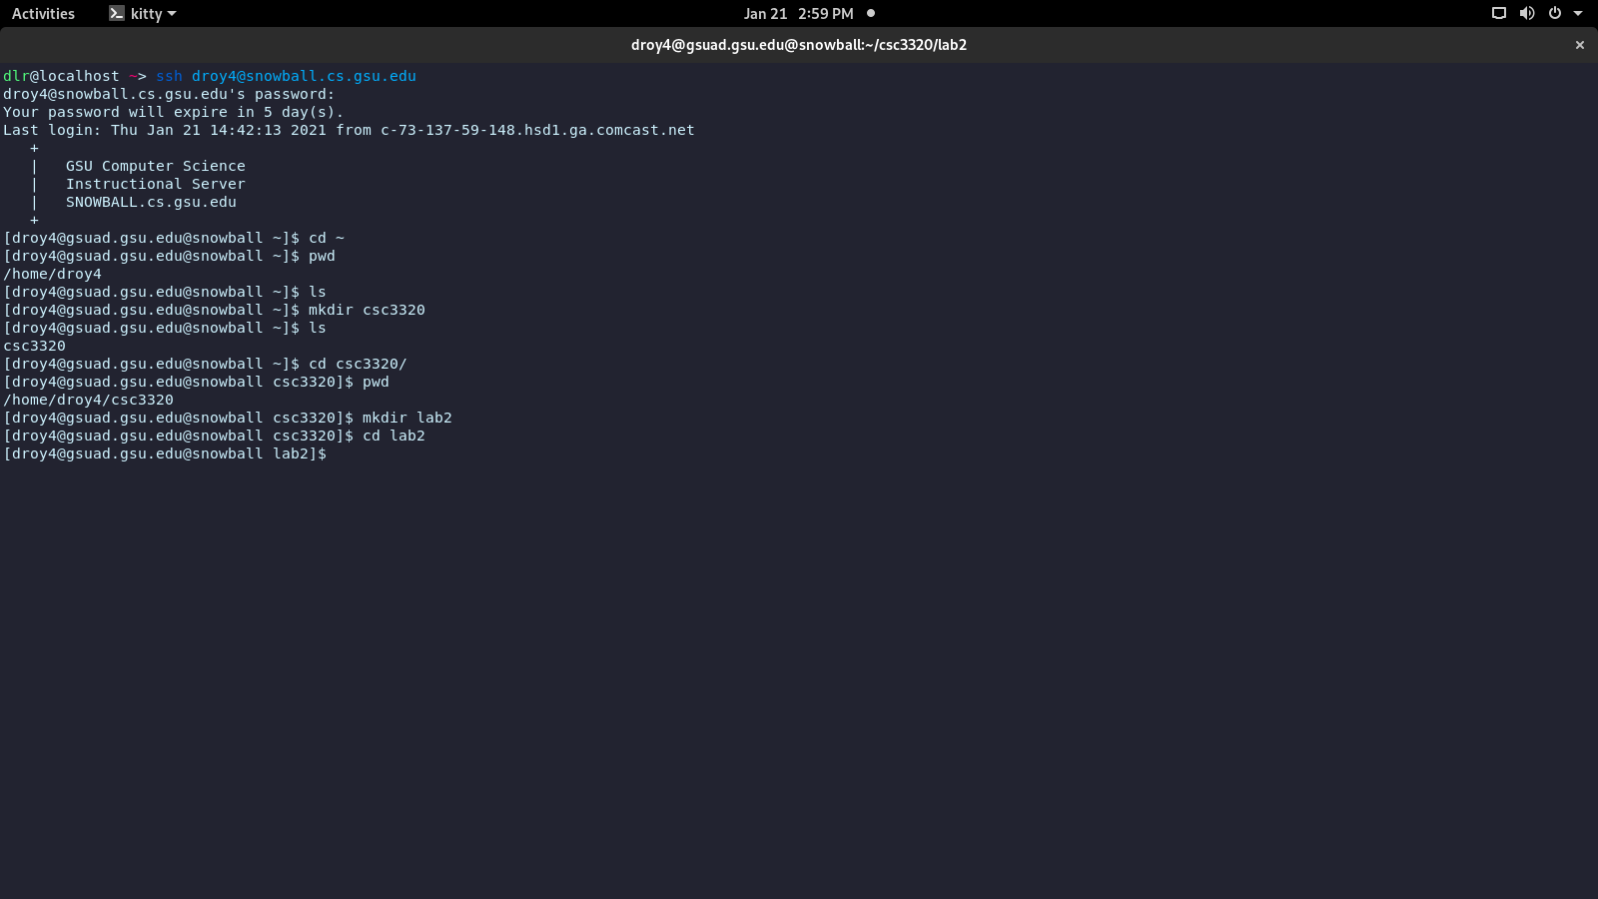

Question E: I used cd to go to my newly created directory.

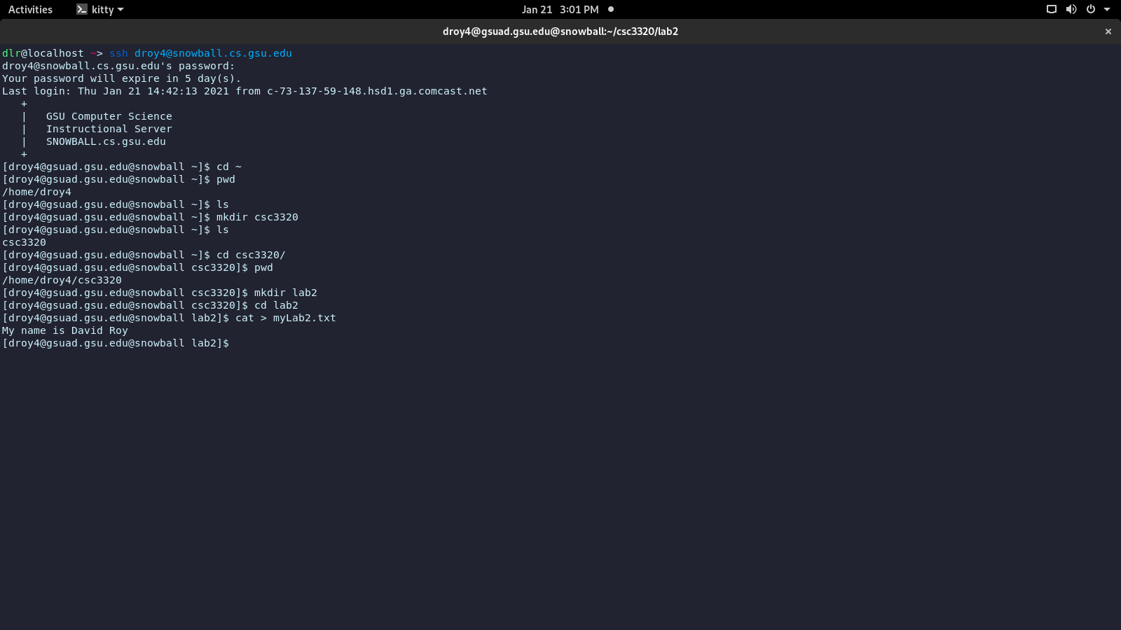

Question F: The special character “>” tells the shell to apply a command to a file.

Question G:

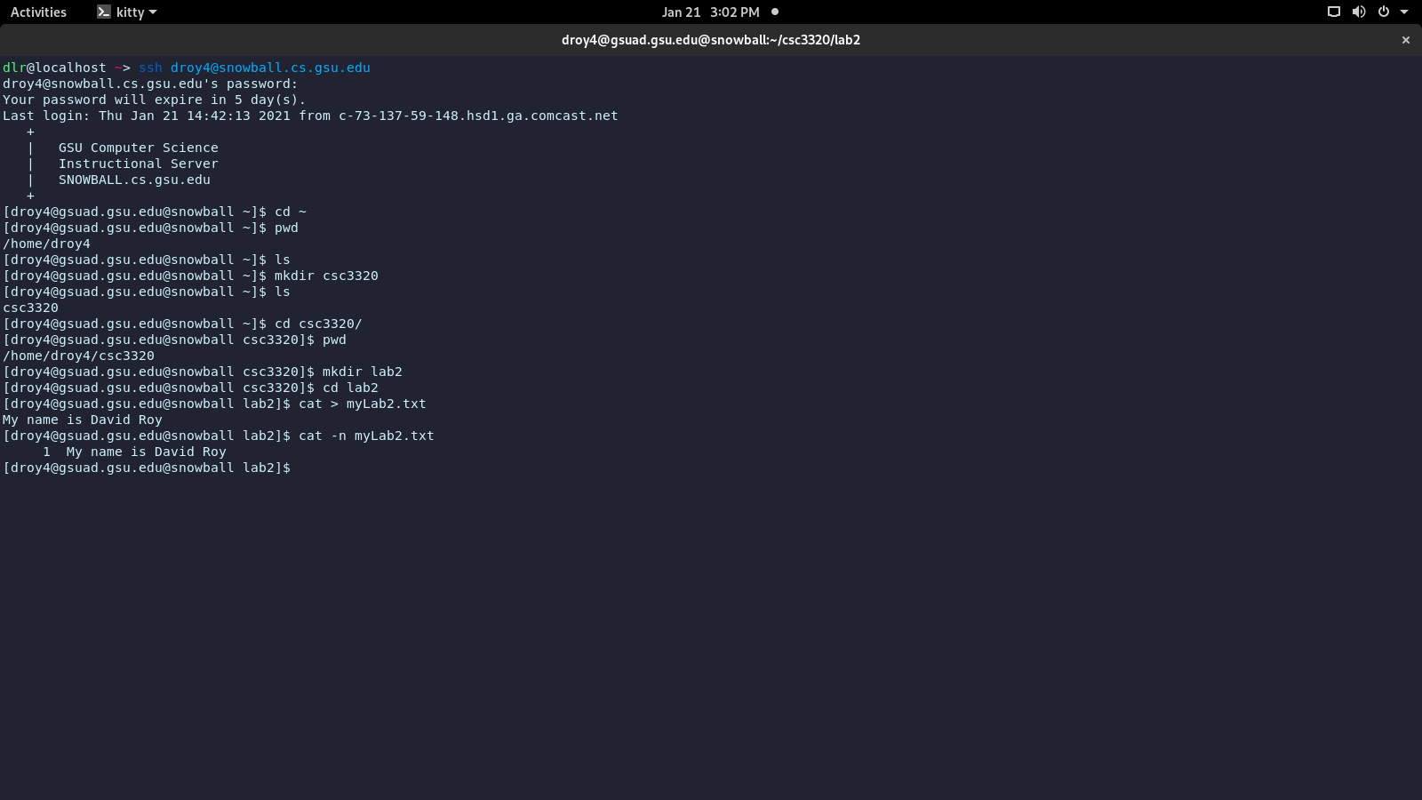

Question H: